All Saints’ National School
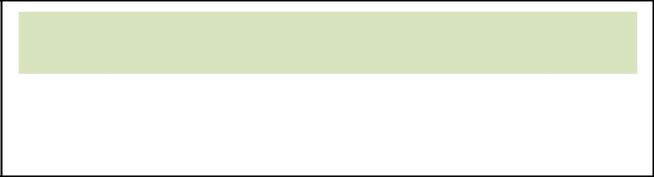

Church Ave,
Mullingar,
Co.Westmeath
Tel. 0449348206

Email: - allsaintsns@gmail.com

Application Form

Sept. 2025

Pupil’s name: ______________________________ | * NOTE: Date of Birth ____ / ____ / ________
 | Date | Month Year
Address: __________________________________ | *A copy of the Birth Certificate must be included with this form
__________________________________________ | Male / Female | Choose one
__________________________________________ | Nationality _____________________
____________ Postal Code ___________________ | **Religion _______________________
 | **Only required for qualification for category 1 ONLY!
Please complete this form for each child (if twins)… | (Refer to Admission for Enrolment Policy)
Contact details
Parent / Guardian: __________________________ | Parent / Guardian: __________________________
Phone No: _______________________________ | Phone No: _______________________________
Relationship to child: _______________________ | Relationship to child: _______________________
Mother / Father / Guardian | Mother / Father / Guardian


Contact email address: __________________________________________________________________

Should my child ________________be offered a place in All Saints’ National School


I declare that:

I agree to the school’s Code of Behaviour

- agree to the school’s Anti-Bullying Policy I agree to the school’s Ethos statement
I enclose a copy of my child’s birth certificate






Parent / Guardian 1 __________________________________ Dated: __________________

Parent / Guardian 2 ___________________________________ Dated: __________________

Note: only for category 1 (refer to our enrolment policy)
Church Membership Declaration must be included with this form (Catg.1 only)

I enclose:
 | Declaration of Church Member (see overleaf) |  |  | 
 | Declaration of Church Member (see overleaf) |  |  | 
 | Statement requesting education under the Church of Ireland Ethos of the school |  |  | 
 | (Your own letter)

Category 1 only - Declaration of Church Membership overleaf (if needed)

**(Under Religion)

Applies to qualification for Category 1 only of enrolment policy (all other categories do not need one of the below):-


- Get this completed by the Minister of your Church Community: -

Declaration of Church Membership

Name of Child:-

Parent (s) or Guardian (s) Name(s)


_______________________________________ _______________________________________ _______________________________________

Address ______________________________________________________________

_______________________________________________________________

I hereby declare, having read the School Admissions & Enrolment Policy (for the purposes of school enrolment), that the above named child is a member of our church community.

________________________________________________________________ Signature of Minister

Date _____________________


Name and address of Church ______________________________________________________

___________________________________________________________________________________

___________________________________________________________________________________


Contact Phone No. __________________________________________________________________

PLEASE NOTE: The above Information may be verified.

